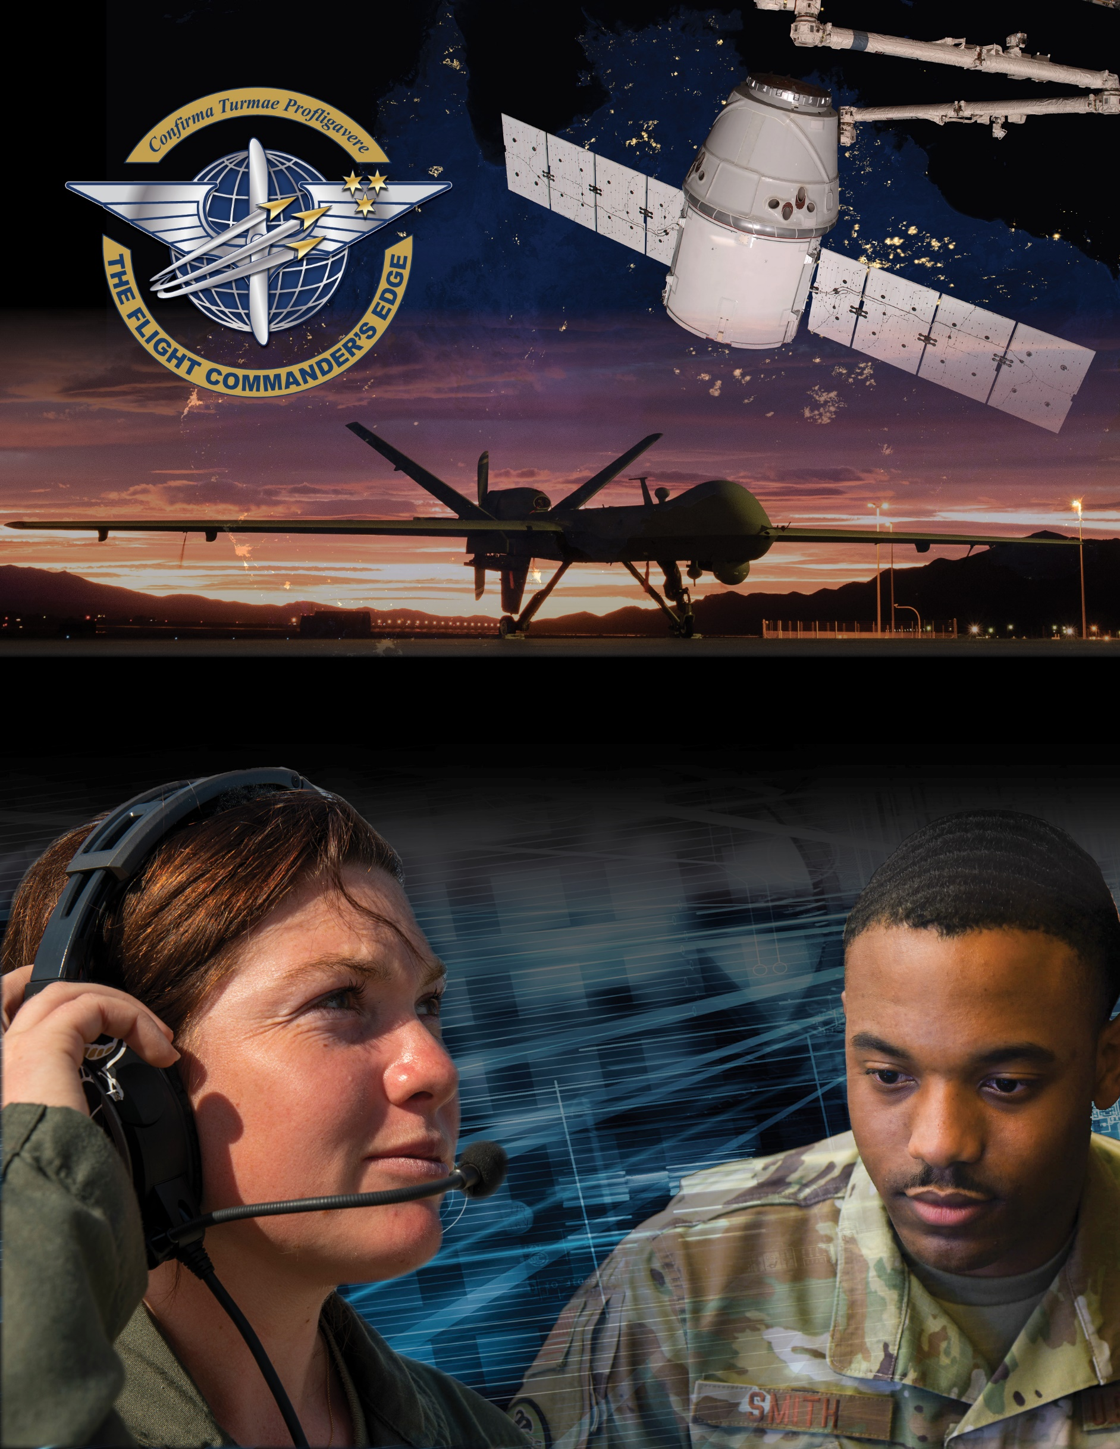

**Lesson Plan**



**Senior Leader Perspective**

***8 April 2025***

**Senior Leader Perspective**

### Purpose

This lesson guide is designed to support the local development of Flight Commander Leadership Course materials. Selected facilitators should use this guide as they prepare presentation materials. For more information on how lessons are structured, or how to use them in the course, see the ***Course Director’s Handbook*** or ***Facilitator’s Resources***.

### Scope

Senior leadership is responsible for establishing and communicating the vision down the chain of command, as well as mentoring aspiring leaders on what can be expected of those in the position of flight leadership. This lesson should be tailored to the level of leadership available to speak to the students (e.g. wing commander, group commander, etc.).

As a Flight Commander you can avoid many pitfalls/mistakes common to first time flight leaders by gaining others’ perspectives and learning from their experience. Senior leaders and commanders have unique insight into what is expected of a flight commander, as well as how to focus one’s time and energy in order to successfully lead at the flight level.

### Recommended Objectives

By the end of this lesson, the participant should be able to:

1. Recognize the expectations and responsibilities inherent to the flight leadership role.
2. Discuss empowerment, intent, unit pride, etc. as it applies to flight leadership.
3. Discuss how the experiences of others can inform successful Flight Commanders.

### Recommended POC / Presenter

* Current/Former Group, Wing, Delta, Garrison, or MAJCOM Commander, vice, or similar

### Recommended Length:

* 45 minutes (inclusive of questions)

### Recommended Approach

* Informal discussion led by Senior Leader(s) *with ample time for Q & A from the audience*

(see next page for potential questions to address)

**Potential Questions for the Senior Leader to Address**

* What issues cause you the greatest concern?
* How do you see the Flight Commander’s role helping with your concerns?
* Based on your perspective and time horizon, what areas of the way ahead are you most excited about?
* If you could go back and change one thing about your early command opportunities, what would it be and why?
* Can you describe a particular “a-ha” moment from your early command opportunities?
* In your view, how does a Flight Commander determine whether a particular risk is worth taking?